Subject Name: Web Development Introduction

Subject Code: WEDE5020

Student Name: Mamukeli Ndiweni

Student Number: ST10541377

Date: 17 April 2026

Assignment: Web Development Project Part 1:
Proposal 1
Boost Force Mobile Car Wash

TABLE OF CONTENTS
1. Organisation Overview .................................................................. Page 1
- 1.1 Business History and Context
- 1.2 Mission and Vision Statements
- 1.3 Target Audience Analysis
2. Website Goals and Objectives ....................................................... Page 1
- 2.1 Primary Business Goals
- 2.2 Key Performance Indicators (KPIs)
3. Proposed Website Features and Functionality ............................... Page 2
- 3.1 Booking and Navigation Features
- 3.2 Mobile-First User Tools
4. Design and User Experience ........................................................... Page 2
- 4.1 Aesthetic and Branding (Color & Typography)
- 4.2 Low-Fidelity Wireframe Concepts
5. Technical Requirements ................................................................. Page 3
- 5.1 Hosting and Domain Infrastructure
- 5.2 Programming Tech Stack
6. Timeline and Milestones (Gantt Chart) ............................................ Page 3
7. Budget Estimate .............................................................................. Page 4
8. References ...................................................................................... Page 4
1. ORGANISATION OVERVIEW

- 1.1 Business History and Context Boost Force Mobile Car Wash is a Cape Town-based startup established in 2026 to disrupt the traditional "queue-based" automotive cleaning industry. As highlighted by Statista (2025), the rise of the South African on-demand economy has created a significant market for services that prioritize consumer time management.

- 1.2 Mission and Vision Statements
Mission: To deliver premium vehicle care with zero time loss for the client.
Vision: To be the premier on-demand detailing partner in the Western Cape.

- 1.3 Target Audience Analysis The primary target includes corporate professionals in office complexes and residents in high-security estates who seek luxury convenience.

2. WEBSITE GOALS AND OBJECTIVES
- 2.1 Primary Business Goals The core goal is to transition from manual bookings to a frictionless one click portal that allows clients to book while working or at home.

- 2.2 Key Performance Indicators (KPIs)
Conversion: Converting 25% of visitors into active bookings.
Efficiency: Reducing booking completion time to under 2 minutes.

3. PROPOSED WEBSITE FEATURES AND FUNCTIONALITY
- 3.1 Booking and Navigation Features
On-Demand Scheduling: A JavaScript-powered form to select service tiers and time slots.
Estate Dropdown: A simplified location selector to minimize user typing.

- 3.2 Mobile-First User Tools
WhatsApp API: A floating button for instant location sharing, a necessity identified by Xneelo South Africa (2026) for mobile service verification.
- Price Grid: A responsive comparison table for various detailing packages.

4. DESIGN AND USER EXPERIENCE
- 4.1 Aesthetic and Branding The site uses an F-pattern layout, placing the "Book Now" CTA where the eye naturally lands (Interaction Design Foundation, 2025).
Palette: Electric Orange (#FF5733) for energy and Slate Grey (#2F4F4F) for professional trust.
Typography: Aptos for headers and Open Sans for body text.

- 4.2 Wireframe Concepts

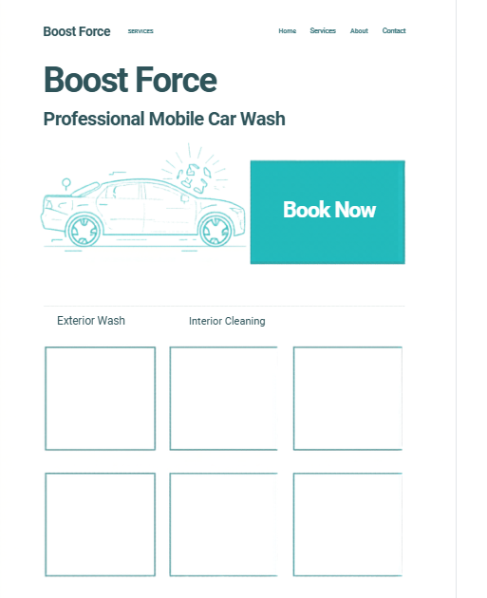

5. TECHNICAL REQUIREMENTS
- 5.1 Hosting and Domain Infrastructure To ensure low latency, the site will use a .co.za domain hosted on local South African servers through Xneelo.

- 5.2 Programming Tech Stack The platform will be built using semantic HTML5, CSS Grid/Flexbox, and JavaScript for form validation.
6. PROJECT TIMELINE
Phase | Task | Mar 15 | Mar 28 | Apr 05 | Apr 15 | Apr 20
1 | Initiation | ████
2 | UI Design |  | ████
3 | Development |  |  | ████
4 | Testing |  |  |  | ████
5 | Deployment |  |  |  |  | ████

7. BUDGET (ZAR)
- Domain & Hosting: R239.00 (Setup)
- Development: R0.00 (Student Project)
- Branding/Photos: R1,500.00
- Maintenance: R150.00 (Monthly)

8. REFERENCES
- Interaction Design Foundation. (2025). Visual hierarchy in web design.
Available at: https://www.interaction-design.org/literature/topics/visual-hierarchy
Accessed: April 2026
- Statista. (2025). On-demand economy trends in South Africa.
Available at: https://www.statista.com
(Search: “on-demand economy South Africa”)
Accessed: April 2026
- Xneelo. (2026). Optimizing local servers for mobile businesses.
Available at: https://xneelo.co.za
Accessed: April 2026

